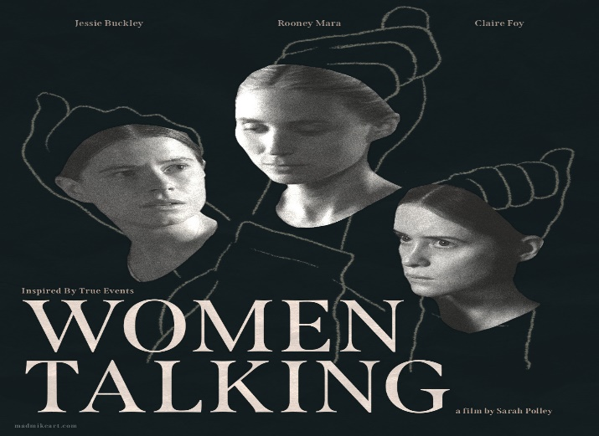

MOVIE NIGHT
January 27th, 2024
6:30 PM
Springs Mennonite Church
Discussion and Light Refreshments to follow.
In a remote Mennonite colony in Bolivia, many girls and women woke up in the morning drowsy and in pain having been attacked in the night. The attacks were attributed to ghosts & demons. Some felt the women were being made to suffer, others thought they were lying for attention or to cover up adultery. Eventually it was revealed that men from the colony had been using animal anesthetic to knock their victims unconscious and rape them. WOMEN TALKING is a creation through fiction to these true-life events.
Movie trailer:
https://www.youtube.com/watch?v=pD0mFhMqDCE
Not recommended for children. If you would like childcare to be arranged at the church, please let Melinda Gibson know.

